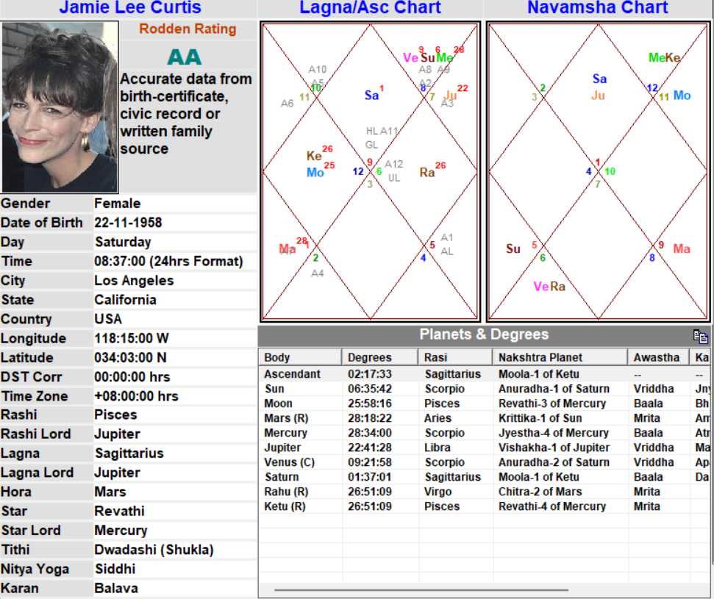

Mars(R) as 5th lord in 5th house - Normal procedures related to matters of children won’t be followed

Timing -

- SInce Mars is at 28 deg (R) = Age of 28 - Adopted a child 1986 (Adopt daughter Annie)

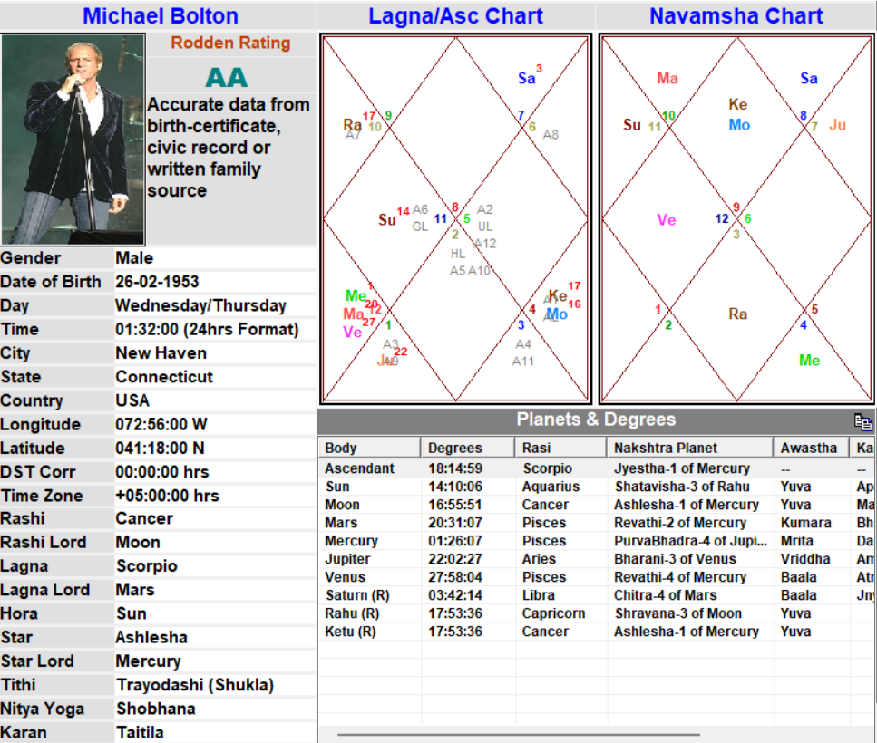

Saturn(R) in 12th house aspected by benefic Jupiter- Extra efforts related to 12th House of foreign-traveling, isolation, charity etc.

Sun being in 4th house native will face conflicts with public, being in sign of Rahu - has to be a issues of blame of cheating / outcasted.

Timing -

- SInce Saturn is at 3.5 deg (R) = Age of 41 - Established the Michael Bolton Foundation which, in 1998, became The Michael Bolton Charities, Inc. for which he has been given honors and awards.
- Since Sun is at 14 deg = Age of 39 - Bolton faced a hostile press corps of critics unhappy with his tendency to copy great soul singers like Redding, Ray Charles, and Percy Sledge. Bolton faced a hostile press corps of critics unhappy with his tendency to copy great soul singers like Redding, Ray Charles, and Percy Sledge

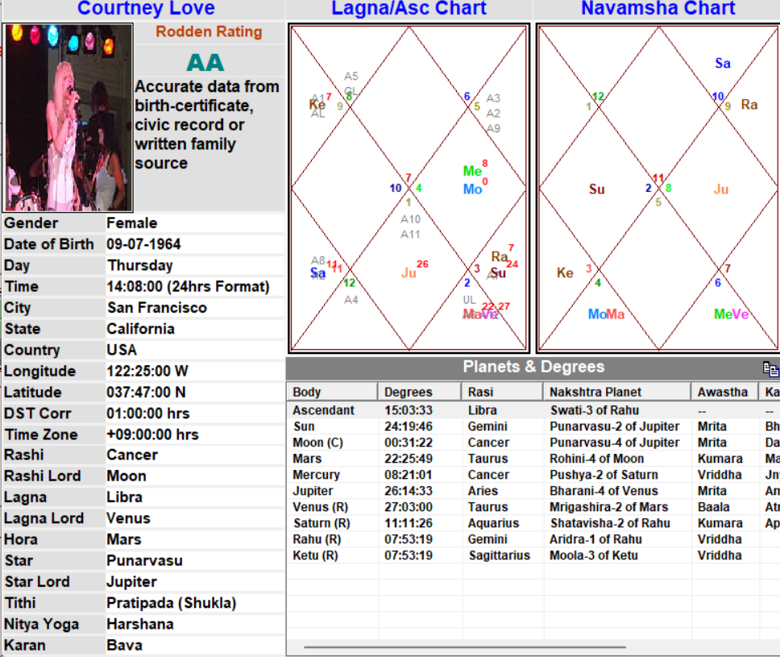

“In October 2003, after several incidents of erratic behavior, Love lost custody of the daughter she had with the rocker Kurt Cobain. On 2 October 2003, Love reported broke into a private home and subsequently ingested a large amount of Oxycontin, a powerful painkiller. She was taken by ambulance to have her stomach pumped. On 10 October, authorities took her 11-year-old daughter Frances into protective custody. Love called a friend threatening suicide and that evening, was checked into a private psychiatric hospital in Pasadena, California. The singer requested rehabilitative services instead but apparently did not complete the course of treatment. On 17 October 2003, she received a report from the Los Angeles Department of Children and Family Services that charged her with abandonment, and a judge gave temporary custody of her daughter to Wendy O’Connor, Kurt Cobain’s mother.”

Saturn(R) in 5th house in Aquarius - Troubles with authorities and bad behavior and odd actions (Saturn - Rahu), struggles related to children and fame.

Timing -

The entire events unfolded in the Saturn Naisargik Dasha, KCD - Aq MD, Vimshottari - Me/ Sa

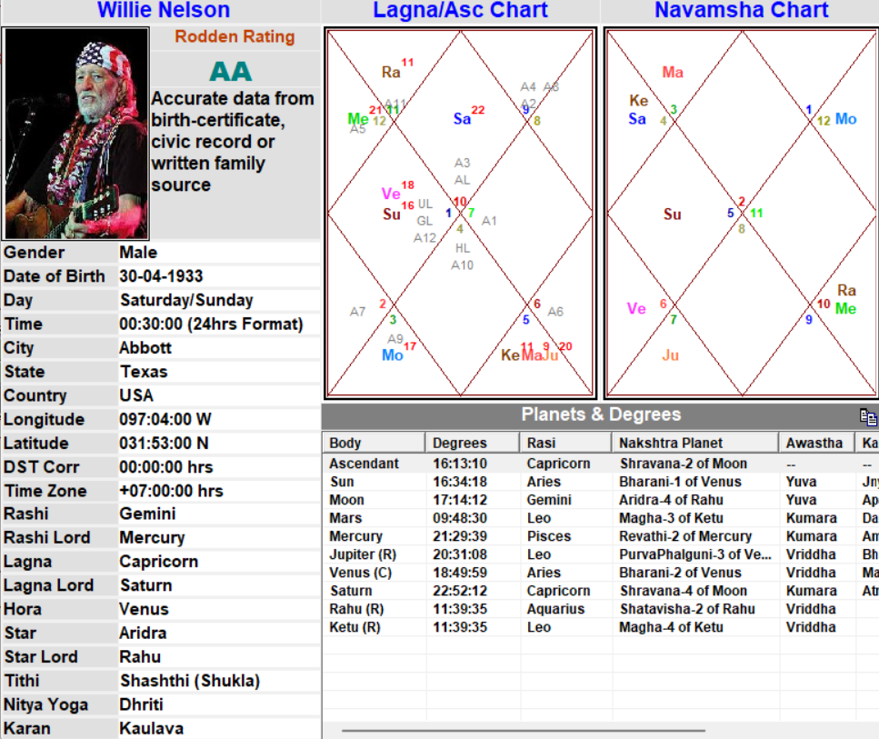

Jupiter(R) in 8th house in royal sign with 11th lord Mars and Ketu - troubles due to significations of Jupiter in terms of finances - wrong financial advices due to which troubles from government / authority.

Sun being in 4th house - Conflicts will affect native’s property / home / metal peace.

Timing -

- Sun is at 16 deg being in conflict with and dispositor of Jupiter(R) - Age of 58 - A former business manager did not file taxes from 1975 to 1982, leaving his finances in a state of ruin. The IRS seized 22 of his properties for back taxes owed of $16 million. When agents raided and locked down his properties on 9 November 1990, he had known they were coming after him but did not hide any assets.

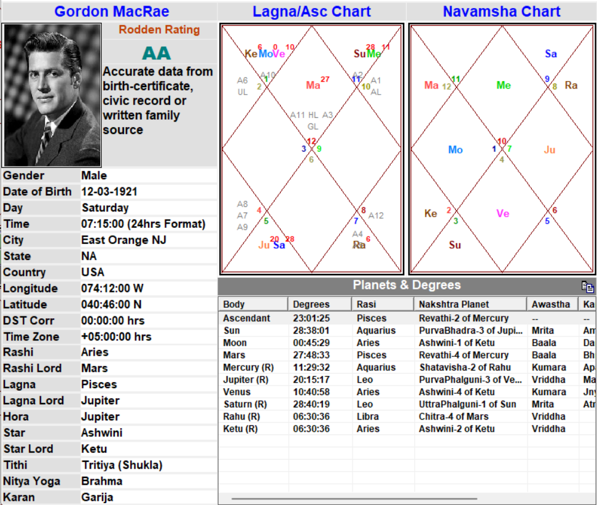

Jupiter(R) and Saturn(R) in 6th house in royal sign - royal punishment.

TIming -

“Lose significant money 1953 (Owed IRS $.5 million in back taxes)”

- VImshottari dasha - Sun MD
- KCD - Leo MD
- Naisargik Dasha - Age of 33 - Mars Dasha

Question -
Why Mars dasha gave the results instead of retro Jupiter / Saturn or Sun?

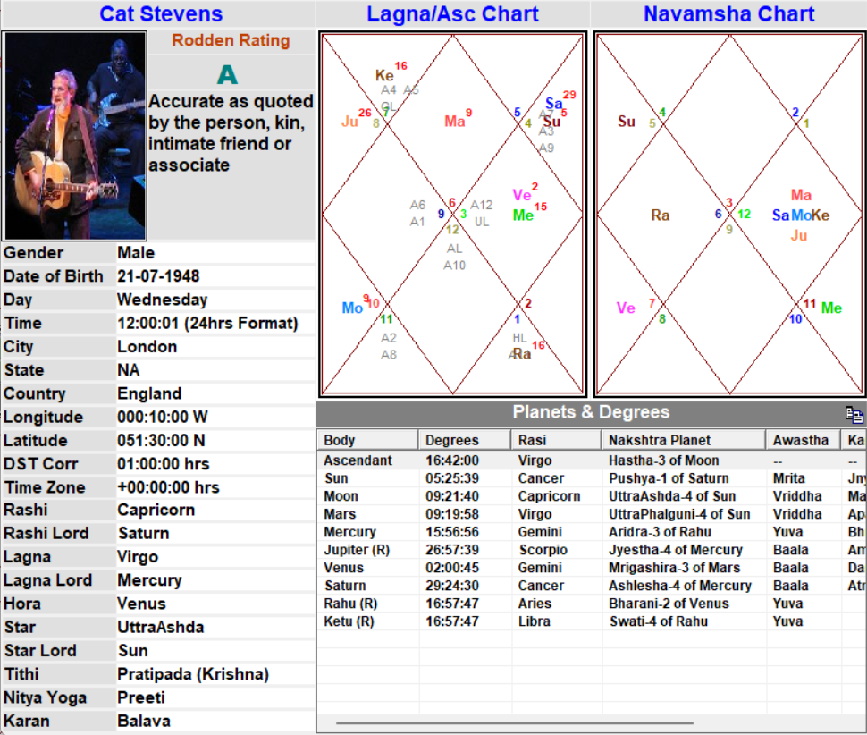

Jupiter(R) in 3rd house in sign of Mars / Ketu - Something odd in terms of religion and being in house of skills / self-efforts / name. Sign of Scorpio - transformation / death.

TIming -

“His spiritual conversion came after nearly drowning at a Malibu beach in 1976, making a deal with God, "Oh, God, if you save me, I'll work for you."
On 22 November 1979, he gave his last performance, giving up his music for the Muslim religion. Stevens changed his name to Yusuf Islam, married a Muslim woman, Fawzia Ali, in the formal tradition and had five children.”

- Naisargik Dasha of Mars - Mars as dispositor of Jupiter(R) and 8th lord gave results (28 and 31)

‘On 22 September 2004, the singer was denied entry into the United States. The plane which he had been allowed to board was en route from London to Washington, but it was diverted to Maine where US officials interviewed Stevens and then arranged for his return to London later that day. As their reason for denying entry, US officials cited that the singer’s name was on one of the country’s "watch lists."’

- Naisargik Dasha of Sun (5 deg) - At 57 Problems happened at security level (Scorpio being ruled by Mars) while traveling, and due to name (3rd house) he had taken during his religious conversion (Jupiter Retrograde)

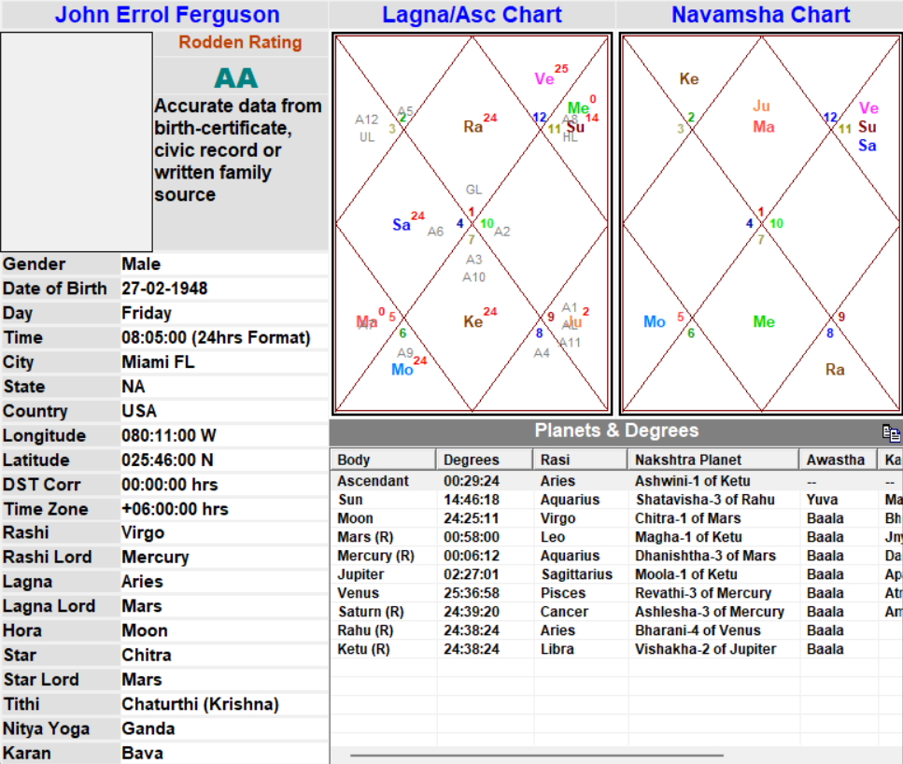

“Rapist/ Sex crime (A number of rapes), Drug business (Drug related crimes), Temper (Violent), Diagnoses : Psychological, Psychotic Episode (Explosive, violent crimes)”

Retrograde malefics in Royal signs - Has issues in all sectors of life. Mars(R) with Rahu in Mars’ sign - Violent temper issues. Saturn(R) - Negative thinking and lack of empathy.

Timing -

- Naisargik Dasha of Mars - Native committed the crimes and was arrested.

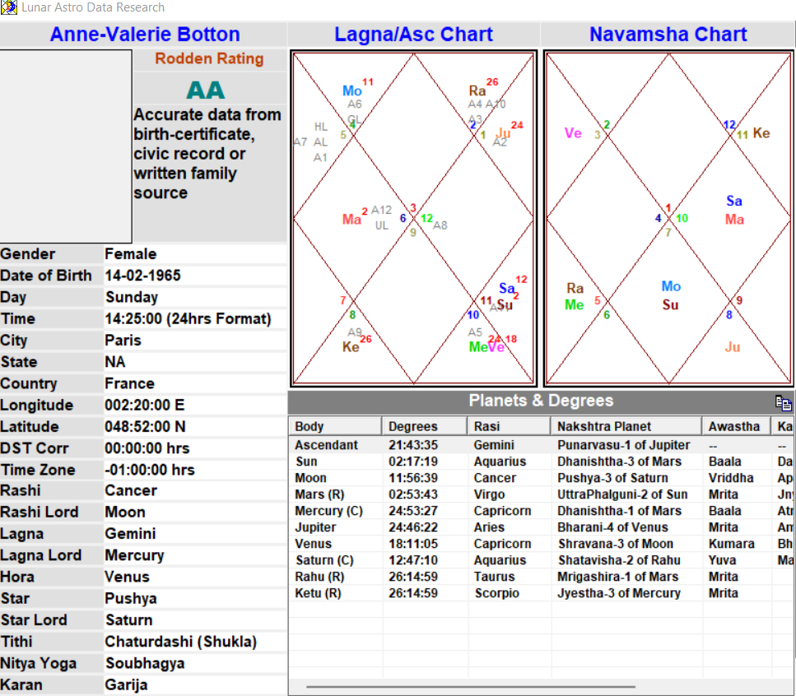

“Her husband, a major "fixer" in the '80s, lived a high-profile life-style until he was arrested for corruption in November 1992, indicted and sentenced in April 1995 for four years, (suspended sentence, fined two million francs and banned from any business operations for five years.) On 12/25/1996 he was hospitalized for a prescription drug overdose. He was released on bail on 4/12/1997. Pierre had been in close business contact with her father, Michael Noir, and during the trial Anne-Valérie's personal diary was taken away and misused by her father to create the impressions he chose.”

Mars(R) in 4th house - Mars being dispositor of 7th lord Jupiter - spouse faced public embarrassment and fights in business from authority, because of native’s father. (Sun in 9th)

Timing -

- Naisargik Dasha of Mars - The entire case started at age of 28. At age of 32, husband hit lowest point.

Question - Degree of Mars in 2 deg, hence results should start from 32-33. But it started at age of 28. Is it because of Sun’s degree being 2 deg?

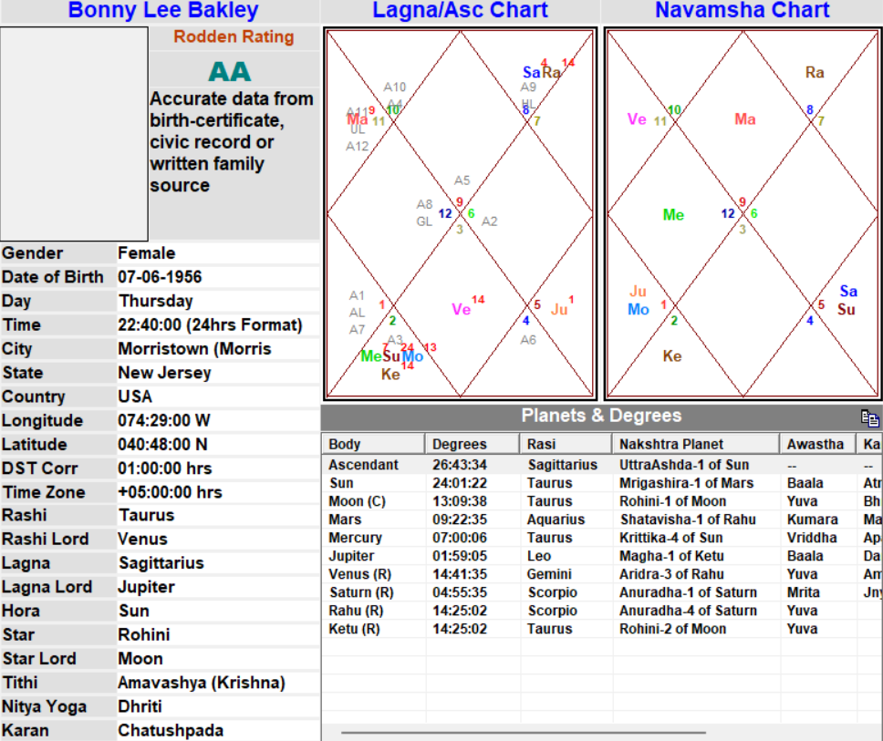

“Bakley married her first cousin Paul Gawron. At roughly five years, this would prove to be the longest of her ten marriages, and they had two children together, Glenn and Holly. The couple divorced in 1982. In an effort to support herself, Bakley began a mail-order business sending nude pictures of women, including herself, to men. She also ran "lonely hearts" ads in magazines advertising for a "male companion". After communicating with the men who answered her ads, she would ask for money for rent or travel expenses.
A pretty girl, she set her sights on either becoming a movie star or marrying one – or both.”

Venus(R) in 7th house in Gemini - Compulsiveness regarding choice of partners, money-matters and in sign of Gemini it would be related to entertainment / fun.
11th lord(R) in 7th in Gemini - Odd ways in earning money through partners through trading / contracts or online.
Saturn(R) with Rahu in Scorpio in 12th - Something odd the native did in isolation where cheating is involved.

Timing -
- Venus at 14.5 deg(R) - At age of 26, major change in relationships and started the odd business related to Venus - Gemini (Trading of pictures of women).
- Saturn at 5 deg(R) - At the age of 41, native was arrested and went to jail for possessing fake identity cards. (Connection to 3rd house)

