With lil knowledge whatever in could understand. Gratitude to you sir.
Chart 2
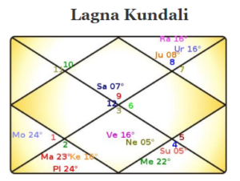

He may be working in connections with set-ups who could be involved in religious/spiritual guidance or training centers connected to healing. Native has support of gurus/ wisdomful people may be from foreign land. (Sa in 9th Sign)
Explaination-he shall be in service to others , & in a start up venture (Sa in 1st H).
10th lord also sitting in 8th house which could be considered that he may make out money through Deep researches/occult/astrology etc & eventually working to give the guidance related to it.
He must be having large amount of followers. Also his life journey involves burning for area of transformations/deeper areas (sun in 8th house)
,Native shall see a rise in career after 45 years (Moon dispositor degree + 10th lord degree ).
Chart 3
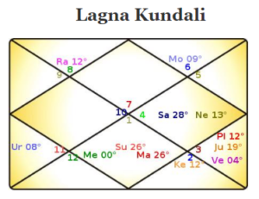

Native shall have to work for the masses may be under concrete organisations wherein he shall have to work hard to provide mental peace /heal. (sa in 10th H , cancer sign)
chart 4
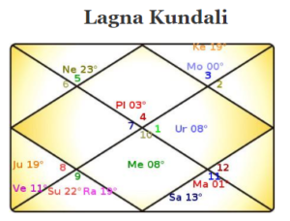

Native shall gain from the healing fields such as occult/astrology/psychology . (“Sa” in 8th H).
He may have to burn entire life offering services to people may be in works related to hospitals/courts where he may be involved in Psycho related realms e.g. psychanalysis centres working for court /or hospitals being involved. (Sun in 6th house)
explaination -10th lord connection to 12th house. He shall be working in connections with upper realms.

