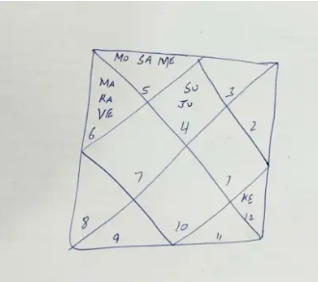

Assignment 1:
Sun
1.Sun in lagna : sun represents ego, independent nature, confidence so native will be egoistic, and independent, confident in nature
Jupiter
2. Jupiter in Lagna: Jupiter represents knowledge and learning, so native will be learned, wise good counseller.
Sun and Moon
3. Sun and Moon are close by one house only, so this persons mind and soul are aligned, indicating stable career and jobs
4. It looks like a chart of Krishna paksha (waning Moon) so the native likes to do things in secret
Saturn
5.Saturn in second house, Saturn represents delays, second house is of earning, so started earning late
6.Saturn represents sorrows, second house is family, so native is sad due to family
7.Saturn represents old age, second house is family, so native’s family is elderly
8.saturn represents old age, second house is face, so native looks older for their age (*doubtful about this)
Moon
9.Moon in second house, moon is mind, second house is family, Native is family oriented and thinks about their family a lot
10.Moon in second house, moon is emotions, second house is earning capacity, so native is sensitive to his earning capacity
11.Moon in second house, moon is emotions, second house is family background, so native is sensitive to his family background
Mercury
12.Mercury is technical intelligence, second house is family, so his family background is well educated
13. Mercury is technical intelligence,second house is earning capacity, so native is earning in the same line as their education
Mars
14.Mars represents Brothers, third house is siblings, so native will have brothers
15.Mars is courage, third house is courage too, so native is very brave, and risk taker, and likes adventures
16.Mars is courage, third house is communication, so native is not afraid to speak his mind
17. Mars is logic and focus , third house is subconcious mind, so native is logical thinker and very focused
Rahu
18.Rahu is “like to keep gathering”, third house is awards/stripes, so native likes to chase awards
19.Rahu is attachments, third house is siblings, native is attached to siblings
20.Rahu is outcast, third house is siblings, so siblings like to live like outcasts
Venus
21.Venus is spouse, third house is neighbors, so spouse must be from the same neighborhood
22. Venus is refinement, third house is speech, so speech is refined
23.Venus is technical knowledge, third house is driving skills, so native is a great driver
24.venus is luxury, third house is short distance travel , so native likes to take luxurious short distance vacations
Ketu
25.Ketu is spirituality , 9th house is religion, so native is spiritual in terms of religion
26.Ketu is lord ganesh, 9 th house is religion, so native love praying to Ganesha
27.Ketu is “ leaving” things, 9 th house is long distance travels, so native hates long distance travels
28.Ketu is detachment, 9 th house is long term goals, native is detached from long term goals
29. Ketu is infections, 9 th house is thighs, native must ve had infections or fractured his legs (since ketu is “broken”)

Questions:
I still haven’t understood how to predict the profession of the native using Saturn only, is it the 10th from Saturn? How to use it?
Thank you!

